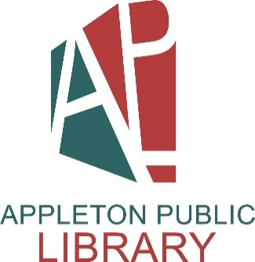
City of Appleton
Appleton Public Library
Library Assistant - Public Services (Half-Time)

The Appleton Public Library, the Wisconsin Library of the Year for 2025, is seeking a Library Assistant - Public Services (Half-Time) to join our dynamic team.

The Library Assistant - Public Services (Half-Time) a half-time, benefited non-exempt library assistant position in the Public Services section of the library. Work involves providing reference, readers' advisory and technology assistance to patrons at the adult public service desks, contributing to locally created databases, fiction and nonfiction collection development and working as a member of the Public Services section. Work is performed under the general supervision of the Public Services supervisor. Some evening and weekend work may be required.

Qualifications
This position requires a Bachelor of Arts or Science degree or a combination of applicable education, experience and training.

Salary
The hiring salary range for this position is $24.07 to $28.88 hourly.

Apply Now!
If you are interested in applying for this position, please complete an on-line application at www.appletonwi.gov by no later than Sunday, June 21, 2026. Resumes without an application will not be considered.

City of Appleton Human Resources
100 N. Appleton Street, 6th floor
Appleton, WI 54911
Phone: (920) 832-6458
Email: humanresources@appletonwi.gov
Equal Opportunity Employer

